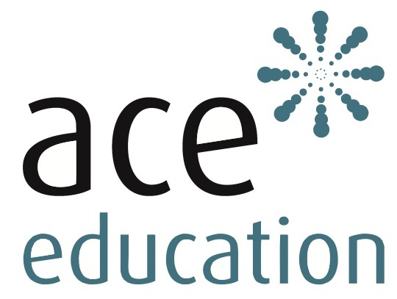
Seminar Booking Form
Download the booking form, complete electronically, save and then email to training@ace-ed.org.uk as an attachment. We will contact you to confirm your booking. Thank you.

Seminar Title:
Seminar Date:

Number of places required:

DELEGATE DETAILS - FOR EACH DELEGATE PLEASE INCLUDE
Name:
Email:
Job title:
Any special requirements (e.g. dietary, access, audio-visual etc):

ORGANISATION DETAILS
Name of organisation:
Address:
Telephone number:

PRICES – ENTER NUMBER OF PLACES IN THE RELEVANT SECTOR

 |  | No. of places
Commercial sector | £315
Public & Charity sector | £275
Small charities (max 5 paid staff) | £215

PAYMENT DETAILS
Contact name for invoice:
Email for invoice:
Telephone number in case of query:

Purchase Order Number (if relevant):

Cheque payments – please make payable to: ACE Education Training LLP (delegate name on reverse) and send to: ACE Education, 72 Durnsford Road, London N11 2EJ

EXTRA TRAINING PACKS
If you have colleagues that are unable to attend the seminar you can purchase the seminar training pack separately at £100. Please send me……copy/ies of …………………………………pack/s

MARKETING
How did you hear about this training? E.g, marketing email, recommendation

CANCELLATION
There is a £50 admin charge for all cancellations. A refund is only given if the cancellation is made at least 21 days before the seminar date. Full terms and conditions are on our website.

YOUR PRIVACY
We will keep your information safe and will not share your details with anyone else for marketing purposes. See the ACE Privacy statement on our website.

